Image | 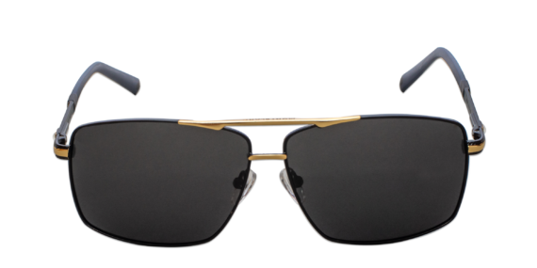
Brand | TOM FORD
Model Name | Marvel SFG
Price | RS 2500
PRODUCT DETAILS

